PARISH NEWS
The Deverills & Crockerton

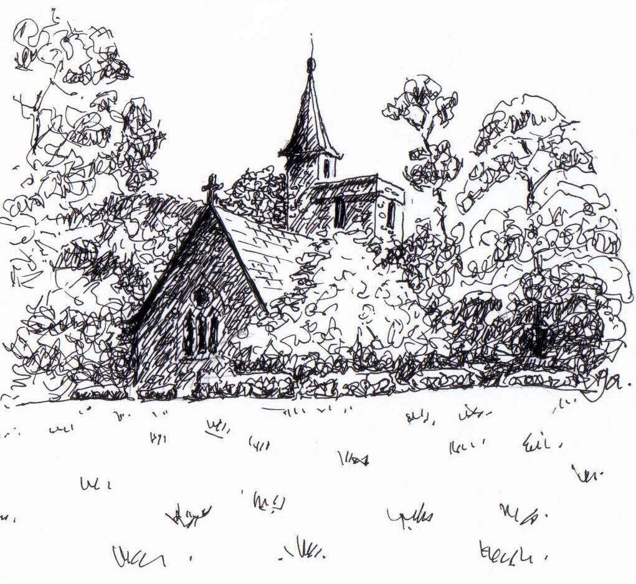

St Mary the Virgin Kingston Deverill
by Pat Armstrong

March 2008

Look inside for local information
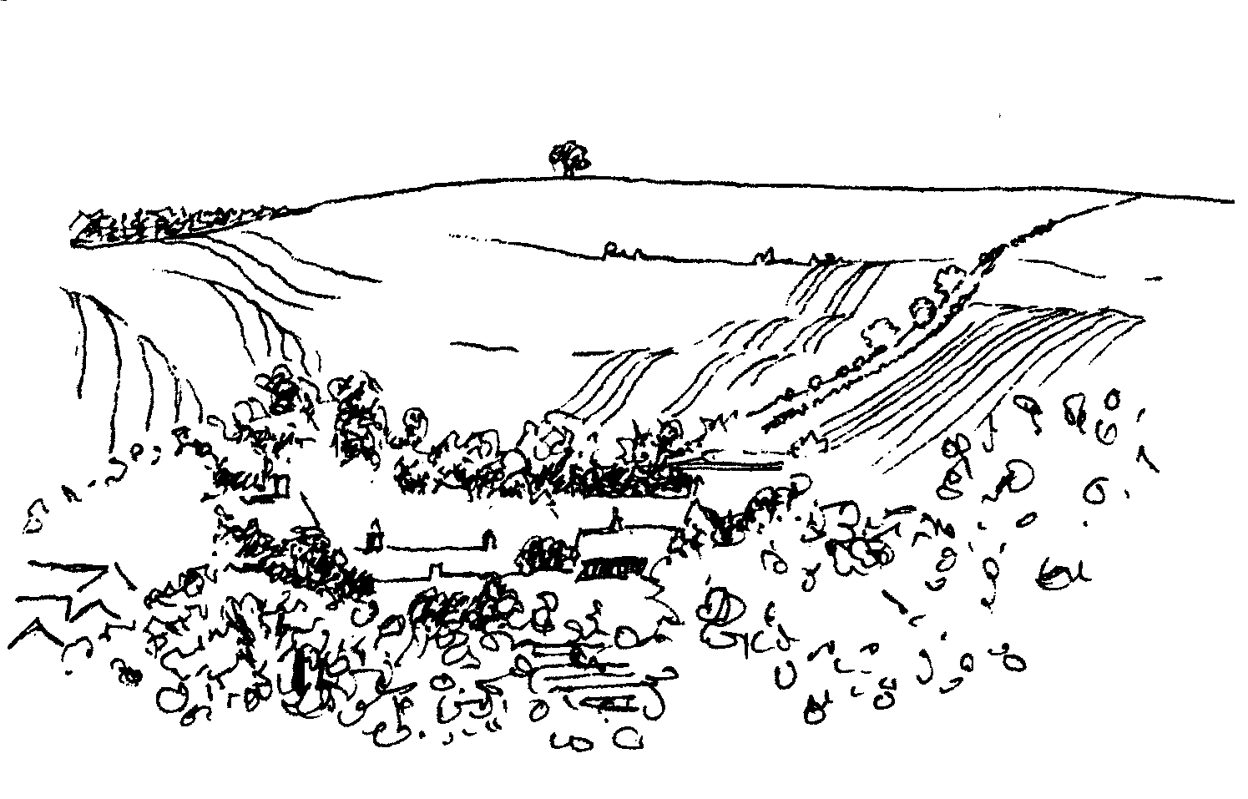

-2-

Salisbury Theatre Club Trips

Monday 17th March ‘People at Sea’ by J B Priestley
Monday 21st April ‘Touched’ by Stephen Lowe
Monday 19th May ‘What the Butler Saw’ by Joe Orton
The cost is £15.00: theatre seat £10.00 and coach trip £5.00
Booking and payment in advance to Mary Stewart Cox Tel 840877
Longmead, Brixton Deverill, Warminster BA12 7EJ
Coach leaves Kingston Church 6.10 pm collects through the Deverills Performances begin at 7.30 pm

Longbridge Deverill Village Hall

HORSE RACING
WITH FISH & CHIP SUPPER
Friday 4th April 7.00 for 7.30 pm

Tickets: £6.00 from Sylvia Titt 214825 or Pat Wood 840535
Come and enjoy a really exciting and entertaining evening
Please bring your own wine

UPPER DEVERILLS VILLAGE HALL

‘Spanish Evening’
Saturday 19th April at 7.30 pm

Tickets £7.50 from Penny Marsh 840828
or Richard Cousens 844970
Come and enjoy a great evening

Please bring your own drinks and glasses

-3-

Computers – convenience or challenge!
Having recently purchased some new computer equipment, but as yet not having had time to install it, I am questioning just how convenient all this technology actually is. I know that this will be successfully done in due time, but possibly not quite as quickly as I would like.
Once we have become sucked into the ‘computer age’, it is difficult to imagine life without the word processor, email, blogs, websites and the rest. Messages are sent with the click of the mouse, and not just to one person but to many!
Since the recent lecture by the Archbishop of Canterbury, the opening contribution to a series of lectures on Islam and English Law, mounted by Temple Church and London University, the immediacy of email has again come into its own. Comments came in thousands to all sorts of sites. Then various opposing views began to be circulated many having a sense of hysteria and wildly polarised opinion (often revealing ignorance of the actual text).
The trouble is that many of us will have received unsolicited email comments about the lecture, which seem to be just as unwelcome (and indeed unbalanced) as the furore provoked by it. I read with interest what Archbishop Rowan said in his presidential address to General Synod. He was at pains to explain the context of his remarks and to challenge those who had not listened to what he was actually saying. We may have opinions about whether our Archbishop should engage in such debate because in so doing he will always be at risk of misinterpretation. But surely, open and honest debate of important issues, which are pressing for the modern world, should not be shied away from. Surely it is right for Christians to engage with the question of the relationship between faith and law. Airing ideas is helpful in clarifying exactly what our views are, especially if it is an issue we have not considered before; the debate is part of that process.
Archbishop Rowan spoke of the privilege it is as Church to be expected to offer a coherent voice on behalf of all the faith communities living here. At Synod he said: “If we can attempt to speak for the liberties and consciences of others in this country as well as our own, we shall, I believe, be doing something we as a Church are called to do in Christ’s name: witnessing to his Lordship, and not compromising it.” Food for Lenten thought!
If the challenge of the computer age and its intrusiveness is too great, there is always the delete button!
Norma Payne - The Rector
Lent Group - Bible Study based on Matthew’s Gospel
This will take place at the Vicarage, Longbridge Deverill on
Tuesday 4th March and Thursday 13th March from 7.30 - 9.00 pm

Lent Group - Bible Study based on Matthew’s Gospel
This will take place at the Vicarage, Longbridge Deverill on
Tuesday 4th March and Thursday 13th March from 7.30 - 9.00 pm
-4-

Annual Revision of the Church Electoral Roll
The period for the revision of the Electoral Roll ends on 15th March in time for the Annual Parochial Church Meeting on Sunday 30th March as indicated on the church notice boards. Please will Parishioners let me know of anyone whose name they think should be removed from the Roll, with a reason please e.g. deceased, moved abroad, etc. There is a copy of the current Electoral Roll on the notice board of each church. Blank Electoral Roll registration forms will be at the back of each church for completion by anyone in the Parish whose name is not on the current Roll and wishes to be included. Please send the completed forms to me at Spring Cottage, Monkton Deverill, or hand them to a Church Warden. Please include on the forms your phone number and the name by which you wish to be known.
M M Tulloch Parish Electoral Roll Officer
Annual Parochial Church Meeting
The Annual Parochial Church Meeting will take place on Sunday 30th March. There will be an Evening Service at 5.30 pm at Longbridge Deverill. This will be followed by the meeting at 6.00 pm in the Village Hall. Refreshments will be served at approximately 7.00 pm.
Easter Workshop For Children
On Friday 21st March there will be a Good Friday Workshop for children from 10.00 am to 11.30 am at Horningsham Village Hall. Things to make and do; a short act of worship to start with; hot chocolate and hot cross buns. There is no charge. It would be good to know who is able to come but not essential. Anyone who is willing to come and help, particularly if they have ideas of something to make, will be especially welcome.
Richard Yates 844374
Salisbury Cathedral 750 years
This year Salisbury will be celebrating the 750th anniversary of the consecration of the completed Cathedral in 1258. The cathedral website: Salisbury cathedral.org.uk shows a full programme of events and activities to mark this milestone during 2008. For example there will be exhibitions, recitals, concerts, medieval fair, art festival, flower festival and many other things so do look on the website and book your tickets.
The Wylye Valley Calendar 2008
Many thanks to everyone who supported Hope and Homes for Children by buying a copy of the calendar. In all, 965 copies were sold, raising a total of £6,525. This money will go to projects which support some of the world’s poorest children – those who are orphaned, abandoned or vulnerable, enabling them to grow up within the love of a family and the security of a home, so that they can fulfil their potential.
Chris Lock

-5-

News, Events in Fairtrade Fortnight, Volunteer Vacancy

I am delighted to share the good news that after two years of campaigning by Warminster Fairtrade Group the town has met all the criteria set by the Fairtrade Foundation for the award of Fairtrade Town. The certificate will be presented to the Mayor, Councillor Veronica Burden at a CELEBRATORY TEA PARTY on Sunday 9th March at 3.00 pm in the Assembly Rooms; this is a free event with live music, all are welcome.
Other Fairtrade Fortnight events:
Saturday 1st March 10.00 - 11.30 am COFFEE MORNING at the Athenaeum to include Fairtrade stalls, raffle and displays.
Thursday 6th March 7.30 pm FILM: BLACK GOLD at Christ Church.
See this film about poor Ethiopian coffee producers and complexities of the international coffee market to understand why our Fairtrade Group worked so hard to increase support for Fairtrade products locally. Free admission - retiring collection.
Saturday 8th March 10.00 am - 12.00 noon COFFEE MORNING at Longbridge Deverill Village Hall offering the chance to chat over coffee and cakes, and a Traidcraft stall.
A message from Harriet Lamb, Executive Director Fairtrade Foundation:
“It may be hard to see how a Fairtrade coffee morning can contribute to a movement changing global economics, but multiply this by 4,000 places of worship (the number of churches holding Fairtrade Church certificates) working towards the same goal, and it makes sense.”
All are welcome, church members or not! Please join us.
Vacancy I shall be moving away from this area later in the year and would very much like to hand over my role as local Traidcraft Fair Trader (volunteer representative) to someone, or some two or three, who would like to take it on. The time involved is as much as you are prepared to give, from as little as an hour or two a week to it taking over your whole life! Please contact me if you’d like to find out more.
Helen Hemingway 841471


As westerners revel in designer lattes and cappuccinos, impoverished Ethiopian coffee growers suffer the bitter taste of injustice. Black Gold traces one man's fight for a fair price.
Award-winning film showing at Christ Church

Thursday March 6th at 7.30pm
Fairtrade refreshments. Free admission. Retiring collection.
“Remarkable - a moving but scandalous story.” - The Daily Telegraph

-6-
Longbridge Deverill Post Office
There is no further news regarding the siting of the Post Office in Longbridge Deverill. The consultation period still continues and I will publish details of any proposals in the Parish News when I have them.
Michael Mounde District Councillor
Deverills Cricket Club Nets Sessions
The Deverills Cricket Club will be warming up for the new season with some practice at the indoor nets at Warminster Cricket Club. All are welcome. We will meet between 6.00 pm - 7.00 pm on:
Sunday 6th April, Sunday 13th April, Sunday 20th April
Jamie Fagan 844123
Concert at St Mary the Virgin, Kingston Deverill
Saturday 3rd May at 8.00 pm
We are delighted to announce that there will be an opportunity to have dinner in the Upper Deverills Village Hall at 6.30 pm before the concert. Combined tickets for dinner and the concert will be £18.00 and are available from Janet Budgen. Call her on 218203 to secure your reservation. Tickets for the concert only will be £10.00 and are available from Julian Wiltshire call him on 844152 to order them; they will also be available on the door. Please book your tickets soon for this very enjoyable occasion. The programme will be made up of piano quartets: Piano Quartet in G minor by Mozart, Piano Quartet in A by Chausson and Piano Quartet in E flat by Dvorak. The players will be Magnus Johnston (violin), Polly Wiltshire (viola), Harriet Wiltshire (cello) and Martin Walker (piano). They have all played in the church: Polly, Hattie and Martin in a concert three years ago, and my nephew Magnus at most Christmas carol services. The concert is in aid of the Deverill Valley Churches Fabric Fund.
Julian Wiltshire
Deverill Valley & Crockerton Women's Institute
Our monthly meeting will take place on Monday 10th March at 7.30 pm in Longbridge Deverill Village Hall. This will be our Annual meeting when we will have a social time playing skittles and scrabble. Please come along and join us, you will be very welcome. For information contact Ann Dufosee on 840360.
Votes for Women!
Presented by The History Wardrobe on Thursday 3rd April in Bourton Village Hall 6.30 pm for 7.00 pm in aid of ‘HELP FOR HEROES’, to build a swimming pool at Headley Court where soldiers who have lost limbs and suffered other injuries are treated. Tickets £15, including supper. Please apply to Mrs Rachael Applegate, Manor Farm Barn, Norton Ferris, Warminster BA12 7HT. Further information from Janet Budgen 218203.

-7-
Longbridge Deverill Village Hall
Valentine Evening - Thank you
Unsuspected talents were revealed at the hall on Saturday 9th February when a very enjoyable music and poetry evening took place. Our gratitude and thanks go to all the performers, to Guy Ratcliffe for his excellent performance as Master of Ceremonies, to John Budgen for spending his evening at the piano and to Nigel Poole as ‘barman’. Thank you also to our loyal supporters and to those who brought food, helped clear up and took home the washing up!
Longbridge Deverill Hall Future Events
Friday 4th April 7.00 for 7.30 pm Horse Racing with Fish & Chips
Horse racing with a difference accompanied by delicious fish and chips supper, please bring your own wine. Tickets £6.00 from Sylvia Titt 214825 or Pat Wood 840535.
Monday 21st April at 7.00 pm Annual General Meeting
This meeting is open to all and the present Committee would be very pleased to hear from anyone wishing to join the Committee or who has new ideas for entertainments or any other suggestions regarding the hall. Please do contact me or a member of the committee (see page 14).
Sunday 27th April 12.00 for 12.30 pm St George's Day Lunch
This two course meal will be followed by tea or coffee but please bring your own wine. Tickets £8 from Sylvia Titt or Pat Wood as above.
Saturday 17th May - Table top sale. Tables £5 each
Saturday 4th October - Harvest Supper
November - Quiz Night
December - Carol Singing
Jo Nelson 840784
Upper Deverills Village Hall
Spanish Evening - 7.30 pm Saturday 19th April
This evening of Spanish food and music is being brought to the Deverills by Penny Marsh and Kevin McBride who brought us last year’s sellout Italian evening. It promises to be just as entertaining. Tickets are £7.50 and are available from Penny Marsh 840828 or Richard Cousens 844970. All proceeds are going towards the Village Hall extension fund for the disabled access and facilities, so please give this event your support. And do remember to bring your own wine and drinks. Spanish, of course!
Albert Lee for Upper Deverills Village Hall

-8-
SERVICES PARISH OF DEVERILLS & HORNINGSHAM

Sunday | Mothering Sunday
2nd March | 2nd March | Holy Communion 1662
 |  | Canon Richard Askew
 | Longbridge - 10.30 am | Morning Worship
 |  | Rev Norma Payne
 | Horningsham - 3.00 pm | Mothering Sunday
 |  | Rev Norma Payne
Sunday | Lent 5
9th March | Kingston - 10.30 am | Holy Communion
 |  | Rev Norma Payne
 | Horningsham - 11.15 am | Holy Communion 1662
 |  | Rev Richard Yates
Sunday | Palm Sunday
16th March | Kingston - 8.00 am | Holy Communion 1662
 |  | Rev John Goodden
 | Longbridge - 10.30 am | Holy Communion
 |  | Rev Norma Payne
Thursday | Maundy Thursday
20th March | Longbridge - 7.00 pm | Holy Communion
 |  | Rev Norma Payne
Friday | Good Friday
21st March | Horningsham Hall - 10.00 am | Good Friday Workshop
 |  | Rev Richard Yates
 | Longbridge - 12.00 noon | Good Friday Service
 |  | Rev Norma Payne
Sunday | Easter Day
23rd March | Longbridge - 8.00 am | Holy Communion 1662
 |  | Canon Richard Askew
 | Kingston - 10.30 am | Holy Communion
 |  | Rev Richard Yates
 | Horningsham - 11.15 am | Holy Communion 1662
 |  | Rev John Goodden
Sunday* | 2nd after Easter
30th March | Horningsham - 10.30 am | Benefice Service Holy Communion
 |  | Rev Norma Payne
 | Longbridge - 5.30 pm | Evening Prayer
 | Longbridge Hall - 6.00 pm | Annual Parochial Church Meeting
Sunday | 3rd after Easter
6th April | Kingston - 8.00 am | Holy Communion 1662
 | Longbridge - 10.30 am | Morning Worship

Tuesday, Wednesday, Thursday, Friday Longbridge 8.30 am Morning Prayer
Wednesday Longbridge 10.15 am Holy Communion

-9-

SERVICES PARISH OF CORSLEY & CHAPMANSLADE

Sunday Mothering Sunday
2nd March Corsley - 9.00 am Family Communion
Rev Norma Payne
Chapmanslade - 4.00 pm Tea Service
Rev Di Britten
Sunday Lent 5
9th March Chapmanslade - 9.00 am Holy Communion
Rev Norma Payne
Temple - 11.00 am Morning Prayer
Col Robin Chappell
Sunday Palm Sunday
16th March Chapmanslade - 9.00 am Family Communion Rev Norma Payne
Corsley - 6.00 pm Compline
Rev Di Britten
Thursday Maundy Thursday
20th March Chapmanslade - 7.00 pm Agape Service
Rev Di Britten
Friday Good Friday
21st March Corsley 10.00 am - 1.00 pm Walk & Worship
Rev Di Britten
Sunday Easter Day
23rd March Temple - 9.00 am Holy Communion 1662
Rev Norma Payne
Corsley - 10.30 am Holy Communion
Rev Norma Payne
Sunday* 2nd After Easter
30th March Benefice Service Holy Communion
Horningsham - 10.30 am Rev Norma Payne
Rev Richard Yates
Rev Di Britten

*PLEASE NOTE: CLOCKS GO FORWARD ON SUNDAY 30TH MARCH

THE DEVERILLS REGISTER
Funeral Service at Kingston Deverill
For Gordon Denis Kent on Friday 22nd February
Thanksgiving Service at Kingston Deverill
For Sally Mary Allard on Friday 29th February

-10-

Ivy House St Denys Retreat Centre
Sunday 16th March
Palm Sunday Lunch & Quiet Afternoon
12.30 - 5.00 pm
For more information please phone 214824

Church Cleaners for March
Kingston – Mrs Beilby & Mrs Noonan
Brixton – Mrs Huntley & Mrs MacDonald
Longbridge - Monday 3rd March 9.30 - 10.30 am - all helpers

Church Flower Arrangers for March
 | Kingston | Brixton | Longbridge
2nd March | Lent | No | Flowers
9th March | Lent | No | Flowers
16th March | Lent | No | Flowers
23 March | Easter | All | Helpers
30th March | Mrs Stratton | Mrs MacDonald | Mrs Robins

CONTACT THE EDITOR AND WEBSITE
Parish News Editor - Judy Munro 844385
Contributions for the Parish News through my letterbox or
by post to Whitepits Lodge, Kingston Deverill, Warminster,
BA12 7HD or by Email: judymunro@tiscali.co.uk Thank you
Please remember the deadline is the 15th of every month

Website: www.deverills.org.uk Email address:info@deverills.org.uk
Website manager : Kate Wilkinson 844998
Contents: Parish News with church services, Parish Register, Events, Local News plus pictures and other information
Contact the Clergy
Please contact Rev Norma Payne (841321) or another member of the Clergy (see back page) if anyone is housebound and would like communion or a visit at home; or if you know of anyone who is ill and needs our prayers; or you wish to discuss any church matter.
Contact the office Administrator by email: office@cleyhill-team.org.uk or by telephone 210149.
-11-

Our Website
Our village website is beginning to grow and I would like to say a big thank you to those who have sent in photographs for the gallery. I particularly like the duck in the tree. Please keep your photographs and ideas coming in. To date our website is the fiftieth most popular on the West Wiltshire Community Website. The statistics are only shown for the top 50 so thankfully we do have some figures. The site was visited 35 times between November and February, I think 30 of those was me! Please send your contributions/ideas to me at info@deverills.org.uk
Kate Wilkinson
Crockerton School Car parking
The issue of traffic flow through the village and parking along the lanes leading to the school is not a new one, but every so often the issue becomes a problem, feelings run high and tempers ignite. The governors and staff of the school would like to assure Crockerton residents that we are acutely aware of the problems that arise because of parking issues and are always looking for creative ways to ease congestion. We are very sorry for the inconvenience that traffic associated with the school can cause residents and would welcome fresh ideas and open discussion to help us find a solution.
At present we operate a ‘stop and drop’ scheme at the start of the school day whereby parent volunteers guide children that are dropped off at the junction of Potters Hill and Jersey Lane up to school and the cars proceed down Broadmead Lane. Traffic flow for this system is one-way and all parents observe this, peak time is between 8.45 - 9.00 am. We do understand that it may be necessary for residents to drive against the flow and, if alerted to this, our parent volunteers will be happy to direct school traffic to facilitate this. At the end of the school day we have staggered class finishing times (3.00 - 3.20pm) to reduce the parking congestion and we also run after-school clubs that finish even later which help to reduce the volume of peak-time parking. The times of buses used to transport children to PE and swimming during school hours are posted on the notice board at the school gate.
The government is keen to reduce the carbon footprint of school travel. It offers grants to schools which have drawn up Travel Plans outlining the school’s active role in promoting alternative forms of transport to car travel. Crockerton’s Travel Plan is available for reading in the school reception. We already operate a ‘walking bus’ to school in the morning and in the spring will be having a ‘cycle to school’ day (via Bradley Road) to see how viable a proposition cycling would be. We encourage car-sharing and have also explored the possibility of a school bus (not viable at present). Our School Travel Committee comprises the governors Linda Searle, Fiona Wolsey and Charlotte Williams (two of whom live in Crockerton). We can be contacted through school and would be pleased to receive any comments or ideas that would lead to positive discussion and help us to make progress with this difficult issue.
Fiona Wolsey

-12-
Parish Guide - Where have you been?
The Three Horseshoes, Batcombe, Somerset
Two pub restaurants feature in this month’s ‘Where have you been?’ The first, The Three Horseshoes, was recommended by Ian and Daphne Woodcock from Longbridge Deverill. They took pot luck there recently for Sunday lunch. They are recommending it because it is a lovely old building with lots of character where they were given a very friendly welcome by the owners who have been there for three years. The pub is obviously well patronised by the locals and the Woodcocks were greeted by a lively buzz of chatter as they walked in. They had an excellent lunch and were so pleased with the place that they plan to return there for dinner in the near future. I know that the pub allows dogs in the bar dining area, presumably accompanied by their owners! The Three Horseshoes is about a 35 minute drive from Longbridge Deverill and is situated west of the Nunney Catch to Bruton road. The telephone number is 01747 850359. Daphne and Ian think they were lucky to get in when they did and advise you to book a table as it is so popular.
The Fox and Hounds, East Knoyle, Wiltshire
The second dining pub is slightly closer to home. The Fox and Hounds is situated on The Green at East Knoyle, a fifteen to twenty minute drive from The Deverills. We visited in December 07, our first time since it has been re-vamped and we were impressed by what had been done to it. The front room, which has the best views over open countryside, used to be a bar with a pool table. It is now a very pleasant dining area with wood floors and a wood burning stove. There are at least three dining areas on different levels varying in atmosphere from the dark area to the rear of the bar with comfortable seats round an open fire to the light and airy conservatory. It was recommended to me by Ranald and Maggie Blue from Brixton Deverill as a good pub to walk to with your dog(s). It takes a leisurely two hours to walk over there from Brixton Deverill (they usually position a car over there and drive back); we think it will be about an hour and a half from Kingston/Monkton. My chief reason for recommending it is as ‘a pub to walk to’ though we were also impressed with the food and the atmosphere. The main bugbear is the very limited parking, not a problem if you walk both ways! The telephone number is 01747 830573. You may wish to be aware that both the pubs recommended here also feature in The Good Pub Guide 2008.
Please keep the contributions rolling in to me, Trish Shuler through my door at Farthings, Kingston Deverill or by email at farthings.kd@btinternet.com. I would be particularly interested to have a contribution from anyone who has tried Bruton House, described as a restaurant with rooms, in Bruton, Somerset. I keep reading good things about it in various magazines but would really appreciate a Crockerton/Deverills view of it.
Trish Shuler 844291

-13-

Nature Notes
The recent spring-like weather has certainly motivated the birds into action. The feeders have been busy, I have noticed great tits and blue tits looking at nest boxes. Male birds of several species are now singing loudly proclaiming their territory: song thrush, blackbird, chaffinch, dunnock, robin, great tit, blue tit and wren. I have also witnessed disputes between males, notably robins and blackbirds. If two robins are feeding happily at the feeders together, they are sure to be a pair. I have noticed how the male bird will stand over the female protecting her while she feeds ensuring that she is in peak breeding condition. I’ve also seen blackbirds do this.
I have started feeding mealworms in the garden and been rewarded with close views of robins and wrens. There is a robin that comes to feed on mealworms from a dish inches away from me while I potter in the greenhouse. He even asks for more! I know it is the male as the brown on top of the head is U-shaped; in the female it is V-shaped. He will take a mealworm and eat it and then often take another disappearing with it, probably taking it to his mate. This is courtship feeding. I can see wrens on the patio wall just outside the kitchen window whilst I eat my breakfast, they move like clockwork toys and are much shyer than the robins taking their mealworms away to eat them privately.
We were getting goldfinches into the garden and to encourage them further I tied some teasel heads to the trunks of the plum trees and sprinkled small seed into them (a mixture of niger, canary and finch seed). This has been a great success and numbers have increased from the 2 or 3 that we were seeing at a time to 6 or 7. I hope these will increase further, they are such pretty birds. The chaffinches and greenfinches have been enjoying the teasel heads too. We have had parties of long-tailed tits visiting the garden, descending onto the peanut feeders and the fat balls. They are very sociable birds chattering to one another all the time with their “pee-pee” and “tick-tick” calls. The party will normally be made up of related birds, parents and youngsters and extended family.
Watching birds at the feeders you can see a definite hierarchy. Within the tit family, the great tit is the dominant species, followed by the blue tit, then the long-tailed tit (they tend to feed as a group so can exert their dominance even though they are small) with the coal tit at the bottom. I was watching a coal tit today and it was sitting in the hedge waiting for the moment when there was a gap at the feeder to zoom quickly and snatch a sunflower heart. Coal tits will often store food because of their position at the bottom of the ‘feeding ladder’. Goldfinches are very noisy at the feeder, I always know when they are there, but starlings are the noisiest and demolish fat balls at an alarming rate!
Temperatures have dipped below freezing in the past few nights; it is amazing that birds can tolerate such cold without suffering hypothermia. Wrens will roost together to keep warm, it is incredible such little birds can cope with low temperatures. But the cold can be a killer if they haven’t found enough food during the day so it is very important to feed the birds at this time of year.
Jane Trollope

-14-

LOCAL COUNCILS, SOCIETIES, GROUPS etc.

Longbridge and Crockerton Parish Council
Bill Hurd 840023 (Chair) Tom Minter 216909
Michael Aplin 840684 (Clerk) Elaine Pidgeon 212878
Julian Algar 840816 Graham Read 840296
Karen Manfield 215526 Peter Whithey 840347
Brian Marshall 214789

Upper Deverills Parish Council
Lady Felicity Wheeler 844683 (Chair) Mike Beilby 844995
Jacqueline Smith 840238 (Clerk) Ranald Blue 841374
Richard Munro 844385 Patricia Shuler 844291

District Councillor
Shear Water Ward - Michael Mounde 844363
Longbridge Deverill Village Hall Committee
Jo Nelson 840784 (Chair)
Barbara Smith 840251 (Secretary) Sylvia Titt 214825 (Caretaker)
Upper Deverills Village Hall
Richard Cousens 844970 (Chair)
Mandy Martyn 844320 (Secretary) John Lea 844325 (Hall bookings)
Crockerton Millennium Committee
Marion Thomas 213739 (Chair)
Pre-School Children and Parents ‘Thursday Group’
Barbara Beilby 844995 (Chair) Sylvia Titt 214825 (Leader)
Deverill Valley & Crockerton W I
Pat Wood 840535 (President) Jill Russell 840209 (Secretary)

Deverills Cricket Club
Peter Child 01963 34593
Jamie Fagan 844123

Wylye Valley Tennis Club
Colin Singer 213696
Wylye Valley Flower Club
Mrs Hazel Yate 215617 (President) Mrs S Scott 213689 (Programme Secretary)
Wiltshire Wildlife Trust
www.wiltshirewildlife.org
Elm Tree Court, Long Street, Devizes SN10 1NJ
Rural Community Beat Officer - Neighbourhood Watch
PC Phil Bridge 0845 408 7000

-15-

FORTHCOMING EVENTS

- Hearing Loss Lip-reading Wednesdays Margaret Head (213259)
- Scottish Dancing Monday Evenings Aline Fry (841054)
- Badminton Mondays & Fridays 3.00 - 5.00 pm Alison Rymell (844819)
- Pre-school & Parents Group Thursdays 10.00 - 11.30 am See p14
- Coffee Morning for Fairtrade Fortnight Saturday 1st March See p5
- ‘Black Gold’ film Thursday 6th March See p5
- ‘Chat over Coffee and Cake’ Saturday 8th March See p5
- Tea Party Sunday 9th March See p5
- Women’s Institute Annual Meeting Monday 10th March See p6
- Wylye Valley Flower Club Nursery Rhymes Tuesday 11th March p14
- Upper Deverills Parish Council Meeting 7.30pm Wednesday 12 March
- Ivy House Palm Sunday Lunch Sunday 16th March See p10
- Salisbury Theatre Club Monday 17th March See p2
- Good Friday Workshop Friday 21st March See p4
- APCM Sunday 30th March See p4
- ‘Votes for Women’ Thursday 3rd April See p6
- Horse Racing with Fish & Chips Friday 4th April See p2/7
- Deverills Cricket Club Nets Sunday 6th April See p6
- Deverills Cricket Club Nets Sunday 13th April See p6
- Spanish Evening Saturday 19th April See p2/7
- Deverills Cricket Club Nets Sunday 20th April See p6
- AGM Longbridge Hall Monday 21st April See p7
- Salisbury Theatre Club Monday 21st April See p2
- St George’s Day Lunch Sunday 27th April See p7
- Concert St Mary's Kingston Deverill Saturday 3rd May See p6
- Table Top Sale Saturday 17th May See p7
- Salisbury Theatre Club Monday 19th May See p2

-16-

PARISH OF THE DEVERILLS
Churches
SS Peter & Paul the Apostles Longbridge Deverill
St Michael the Archangel Brixton Deverill
St Mary the Virgin Kingston Deverill
Rector
Rev Norma Payne, 6 Homefields, Longbridge Deverill 841321
Clergy
Rev Richard Yates, 212 Pottle Street, Horningsham 844374
Rev Diana Britten, 69 Lane End, Corsley 01373 832515
Readers
Mr John Budgen, Woodlands, Sutton End, Crockerton 218203
Col Robin Chappell, 7 Elm Hill, Warminster 212153
Churchwardens
Mrs Elisabeth Atkinson, 133 Foxholes, Crockerton 212129
Mr Nigel Poole, 7 Homefields, Longbridge Deverill 840902
Mrs Mary Stewart Cox, Longmead, Brixton Deverill 840877
Major Mike Tulloch, Spring Cottage, Monkton Deverill 844381
Lay Pastoral Assistant Co-ordinator
Rev Norma Payne, 6 Homefields, Longbridge Deverill 84l321
PCC Treasurer
Mr David Stratton, Manor Farm, Kingston Deverill 844549
PCC Secretary
Mrs Anne Honley, Dry Hill House, Crockerton 215956
Church Electoral Roll Officer
Major Mike Tulloch, Spring Cottage, Monkton Deverill 844381
Parish News Editor
Mrs Judy Munro, Whitepits Lodge, Kingston Deverill 844385
Organist
Mr John Budgen, Woodlands, Sutton End, Crockerton 218203
Tower Captain
Mr Stephen Young, 68 Highbury Park, Warminster 212796
Caretaker - Longbridge Church
Mrs Sylvia Titt, 7 Church Street, Longbridge Deverill 214825
Office Administrator (Mon-Fri 10.00 - 12.00)
Mr Dick Collins, 22 Church Street, Warminster 210149

